**Data Analysis and Prediction Report for Employee Characteristics**

Introduction

The dataset contains employee information, including age, gender, marital status, monthly income, and educational background.

The aim of this analysis is to explore employee characteristics and develop a predictive model to forecast monthly income.

Data Preprocessing

Handling Null Values: Addressed missing values in the dataset.

Feature Selection: Dropped unnecessary columns not relevant to the analysis.

And here we handle the null values and we found no null values as below

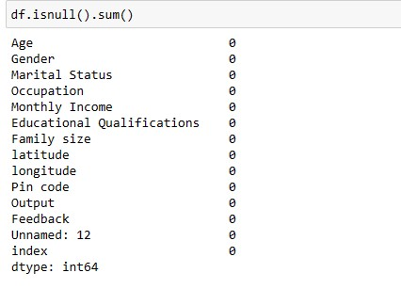

Categorical Feature Encoding: Converted categorical columns to numerical values. For instance, assigned numerical labels to gender (0 for Female, 1 for Male), and educational background (0 for Uneducated, 1 for Student, 2 for Graduate, 3 for Postgraduate, 4 for PhD).as below

**first we assign the numerical values to each catogory of the each feature as below**

**Gender:**

**female=0**

**male=1**

**Marital Status:**

**single=0**

**married=1**

**prefer not to say =2**

**occupation:**

**Student:0**

**Employee:1**

**Self Employeed:2**

**House wife:3**

**monthly income:**

**No Income=0**

**Below Rs.10000=1**

**More than 50000=2**

**10001 to 25000=3**

**25001 to 50000=4**

**Educational Qualifications:**

**Post Graduate=0**

**Graduate=1**

**Ph.d=2**

**Uneducated=3**

**School=4**

**output:**

**no=0**

**yes=1**

**feedback:**

**negitive=0 positive=1**

Exploratory Data Analysis (EDA)

Conducted correlation analysis between features to identify relationships.

Utilized appropriate visualization techniques (scatter plots, heatmaps) to explore correlations.

Here are some of the scatter plots that show the relations between monthly income and other features

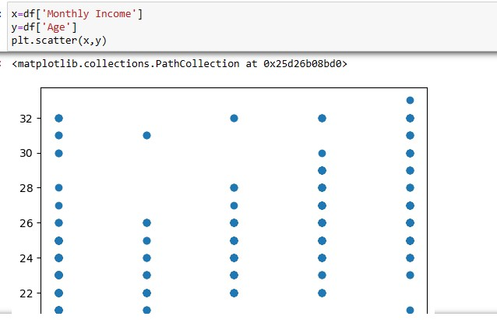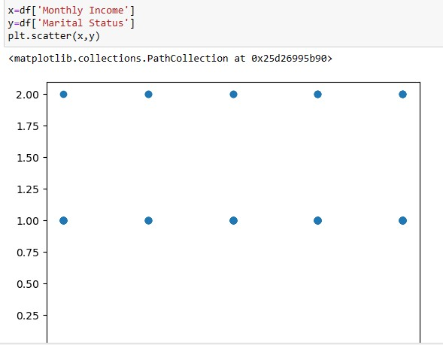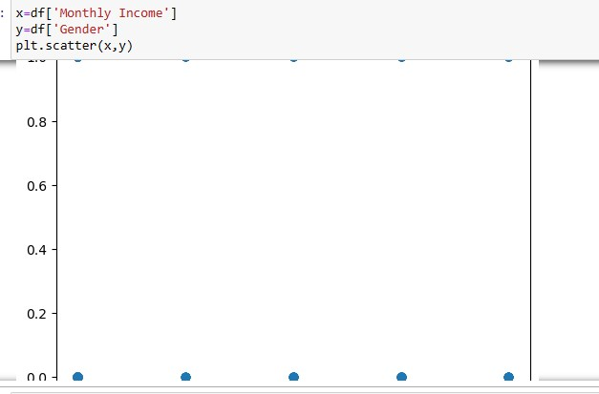

**Predictive Modeling**

Feature Selection: Chose relevant features for predicting monthly income.

Model Training: Developed a predictive model using suitable algorithms (e.g., linear regression, random forest) to forecast monthly income.

5. Results

Correlation Analysis: Identified significant correlations between features and monthly income.

Model Performance: Evaluated the predictive model's accuracy and precision.

6. Visualization

Generated visualizations illustrating the relationship between actual and predicted monthly income values.

Conclusion

The developed predictive model demonstrates reasonable accuracy in forecasting monthly income based on employee characteristics.

Insights gained from the analysis can inform decision-making processes in human resources and organizational planning.

Future Steps

Explore additional factors or features that may enhance the predictive model's performance.

Continuously refine and update the model to adapt to changing employee demographics and organizational dynamics.

References

Include any references to datasets, methodologies, or literature used in the analysis.

This report provides a structured overview of the data analysis process, from preprocessing to predictive modeling, and highlights key findings and insights obtained from the analysis. If there are any specific details or analyses you'd like to emphasize further, please let me know, and I can tailor the report accordingly.